Stop creating desktop.ini files

If you want to stop these files from being created, you can do so by changing the Windows registry.

1. Press the Win + R keyboard shortcut to open the Run box.

2. In the Run box, type "regedit" and press enter.

**[Use Google Maps Go as a lightweight alternative to Google Maps](https://en.iguru.gr/google-maps-go-a-lite-solution/" \t "_self)**

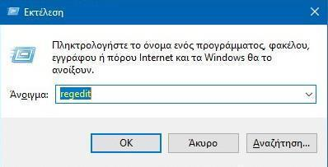

3. The registry editor will open. There go to the following key.  
HKEY\_LOCAL\_MACHINE \ SOFTWARE \ Microsoft \ Windows \ CurrentVersion \ Policies \ Explorer

4. Look for a DWORD value called **UseDesktopIniCache**. Double click on it and set its value to 0.  
If the value does not exist, right-click in the right pane and select Create> DWORD Value (32-bit) and name it UseDesktopIniCache. By default, the value must be set to 0 (zero).

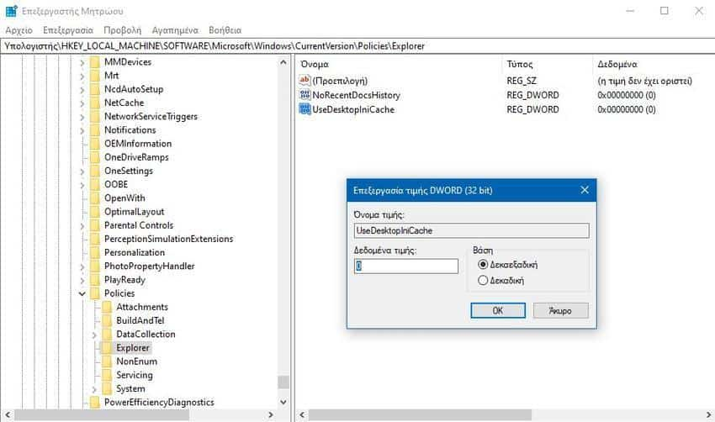

You can now delete the desktop.ini files and they will no longer be created. You can even customize folder views.